MGE313 Time-Series Analysis Term project

Analysis of international economy

20161387 JeongHwan Choi

Contents

1. Introduction -------------------------------------------------------------- p3-4

2. Assumption & Limitation ---------------------------------------------- p5

3. IS-LM model ------------------------------------------------------------ p6-8

4. Object --------------------------------------------------------------------- p9

5. Analysis Time series data ---------------------------------------------- p10-30

6. Analysis economy factors through IS-LM model ------------------- p30-34

7.Vector Autoregression --------------------------------------------------- p35-39

8. Conclusion --------------------------------------------------------------- p39-41

9.Appendix ------------------------------------------------------------------ p42-54

Introduction

Nowadays, because of COVID-19, international economy situation changed significantly. Each country uses expanded monetary and fiscal policy to boost their domestic economy.

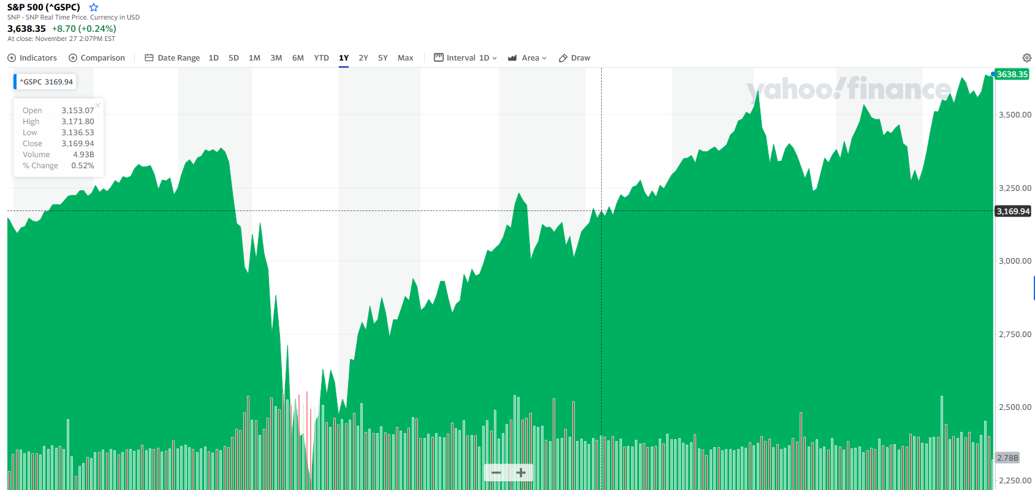

<S&P 500 from YAHOO Finance>

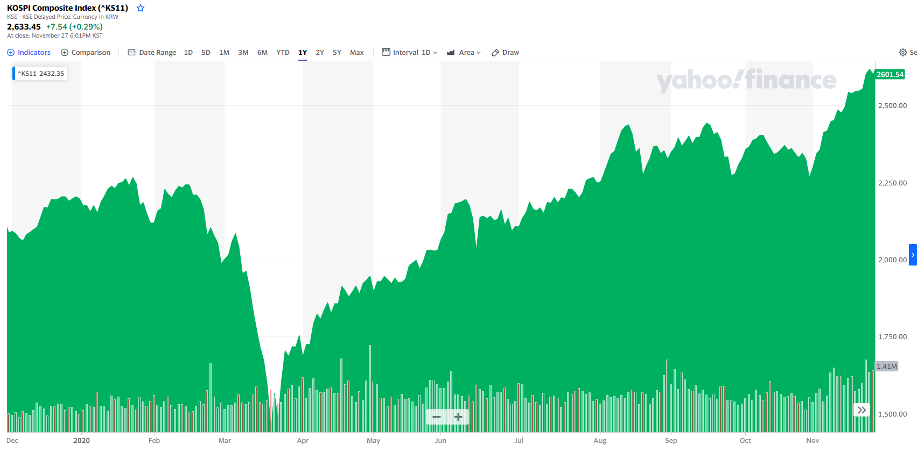

<KOSPI Composite Index from YAHOO Finance>

As you can see from above market index, there was huge recession right after COVID-19 broken out, however market recovered as time goes by.

In this term project, through using time-series data, we will analysis current situation, predict future economy factors through time-series model and IS-LM model. After that, we will discuss about future GDP and stock market.

Assumption & Limitation

* Assumption

1) Define foreign country as USA and home country as South Korea for simplify analysis.

2) Use simple IS-LM model and concept, assumption of Keynesian cross to analysis macro economy.

* Limitation

1) Because of defining just one foreign country(USA), there can be some gaps between real world economy situation

2) There can be many other factors that affect to economy situation that will not be considered in this project. In short, the result from this project is abbreviation of real economy.

3) All values we will predict come from past time-series data. As a result, we can not guarantee that there will be no external economy shock. In other words, other economy shocks can affect to macro economy.

IS-LM model

* Introduction

IS-LM model is model that analysis relationship between interest rate and GDP. It can reflect monetary policy and fiscal policy so it is simple tool for analysis macro economy.

* Economic variables

1. Total expenditure
   1. Consumption : )

Consumption is proportional to GDP and decreased when tax increased

* 1. Investment : I(r)

Investment factor has inverse proportional relationship to interest rate

* 1. Government Policy : G(Government expenditure), T(Taxes)

Assume tax is fixed

* 1. Trade balance :

Trade balance is proportional to exchange rate against foreign countries

Trade balance is inverse proportional to household income

Trade balance is proportional to foreign countries household income

* 1. Planned expenditure (PE) : C + I + G + TB
  2. Actual expenditure (AE) : Y (GDP = GNE = GNI in closed economy)

If economy is in equilibrium, PE = AE

1. Money supply & demand
   1. Real money supply : (M = money supply, P = price level,)
   2. Money demand : L(Y, r)

Money demand proportional to household income and inverse proportional to interest rate

If economy is in equilibrium, real money supply = money demand

= L(Y, r)

1. Foreign exchange market
   1. Base on UIP(Uncovered Interest rate parity)

UIP Approximation :

This theory assumes that there is no arbitrage opportunity by interest rate between two countries in efficient market. Although one country interest rate goes up, exchange rate will compensate that change by depreciation.

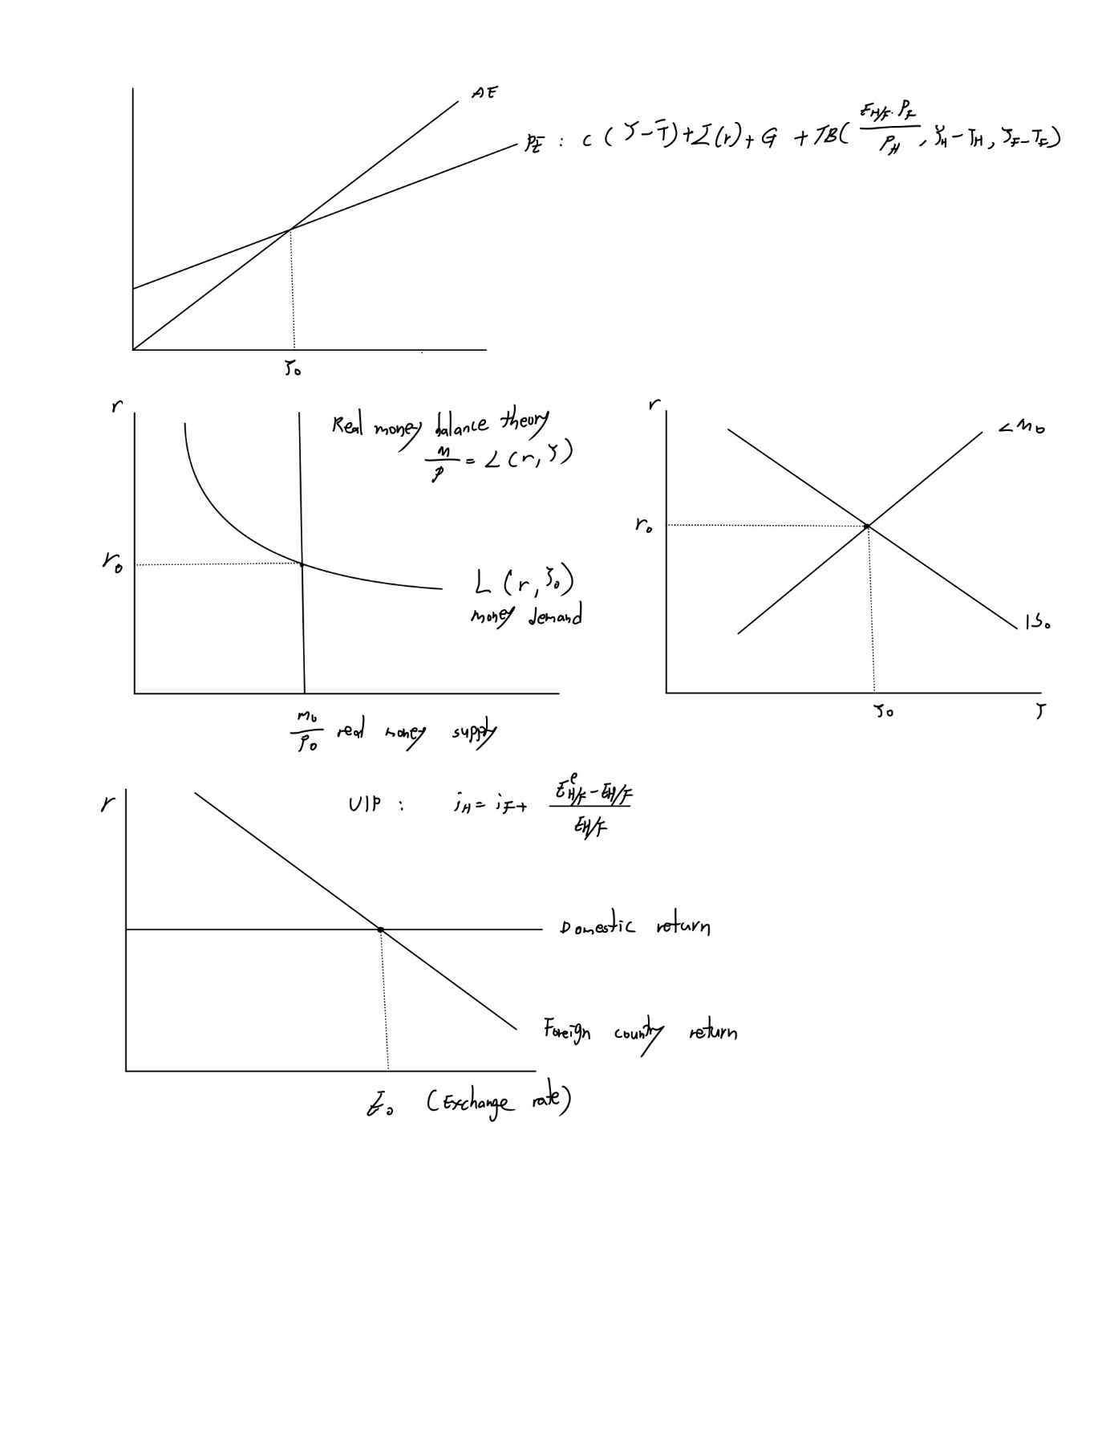

This is final shape of model. In this project, through changing government expenditure(fiscal policy) and money supply(monetary policy), we will observe how other economy factors will change.

Object

* Through analysis government monetary and fiscal policy through time-series data, predict future economy situation
* Compare prediction of IS-LM model and time-series model whether they derive same result
* Provide solution to KOREA economy

Analysis percentage change of M1 money supply data stationary

* Before we do modeling we should check whether data is stationary or not

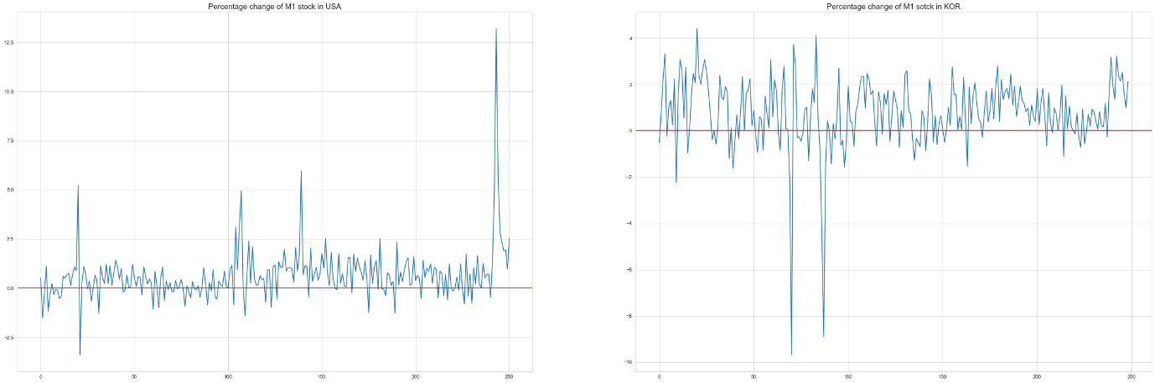

Above image shows M1 money supply data before preprocessing. Left image is M1 money supply of USA and right image is M1 money supply of Korea. It looks like none stationary process because they volatile very much.

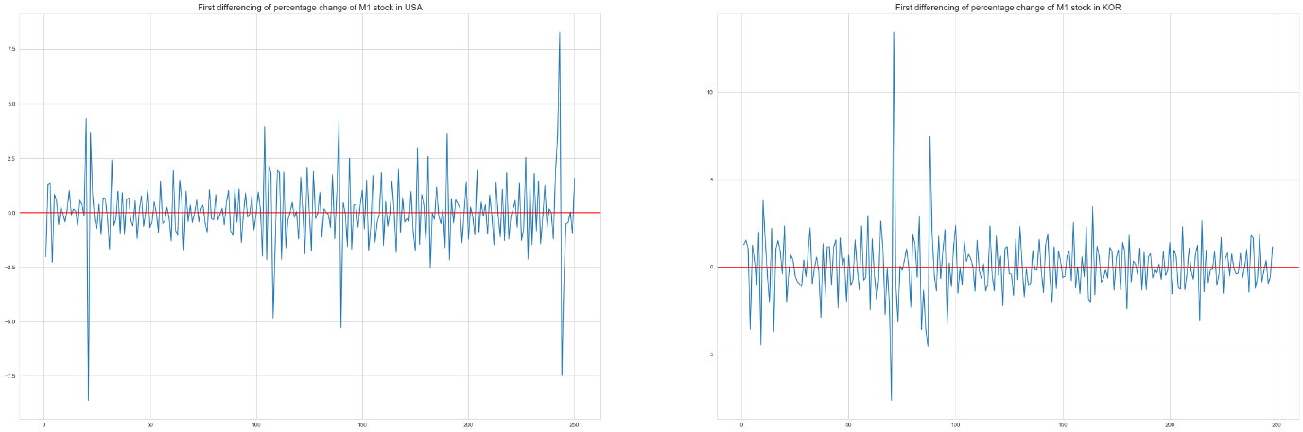

After doing first differencing, it looks more closer to stationary process.

Modeling and predict percentage change of M1 money supply

* Through analysis M1 money supply, we will see how much money central bank supply to market.
* For analysis M1 money supply, I use Seasonal ARIMA and set frequency as 12.
* Data unit is percentage change per period(1 month)

⬩ USA M1 money supply

1. Check ACF and PACF

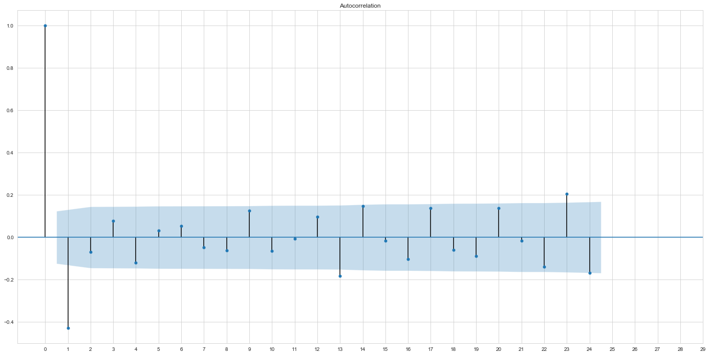

Above image is autocorrelation function. It looks like cut off after time lag 1.

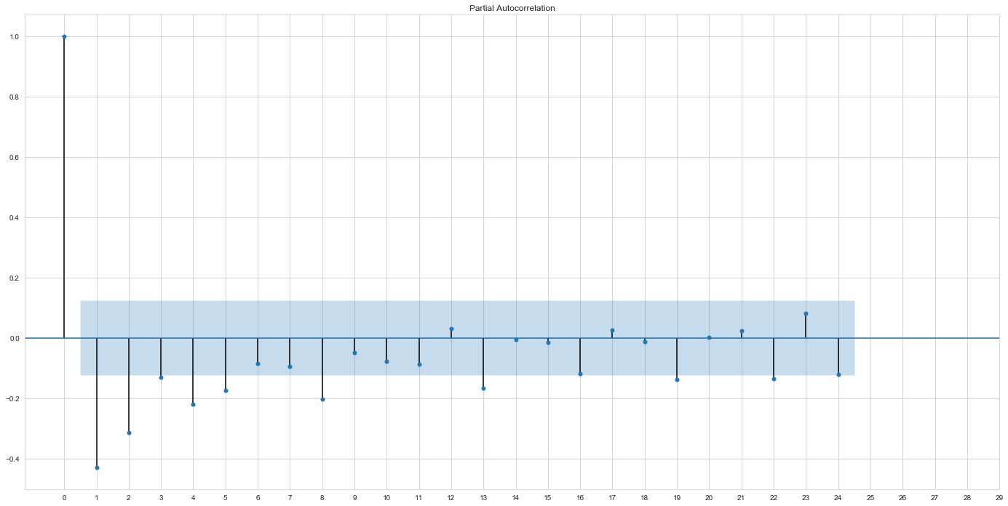

Above image is PACF. It tails off. I can suggest using ARIMA(0,1,1) or ARIMA(8,1,0) model. In this case I will use ARIMA(8,1,0) model.

2. Check seasonality

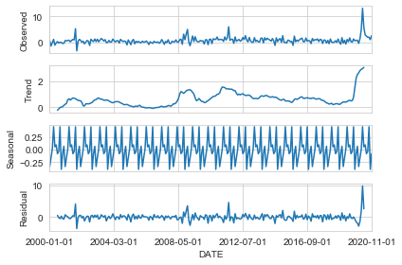

Above image shows seasonality through setting frequency as 12(=1 year). We can know that there is seasonality in our data.

3. Modeling

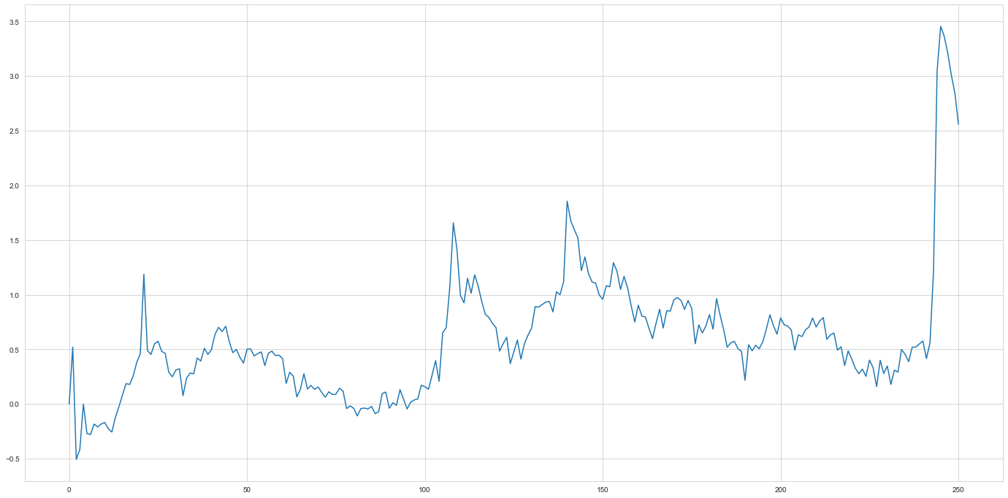

As I mentioned above, we use ARIMA(8,1,0) with seasonality. As a result, I fitted data to SARIMAX(8,1,0,12) model.

[STAT1]

As you can see, all parameters are bigger than std error, data fitted well to model.

4. Check residual

For checking whether our data fitted well, we should see residual doesn’t have correlation and follow normal distribution.

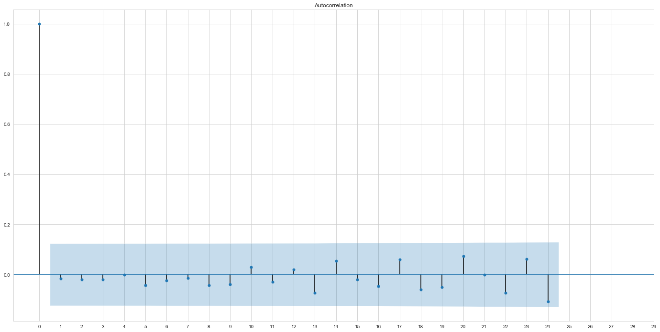

Above image shows autocorrelation of residual and we can know that there is no correlation between residual.

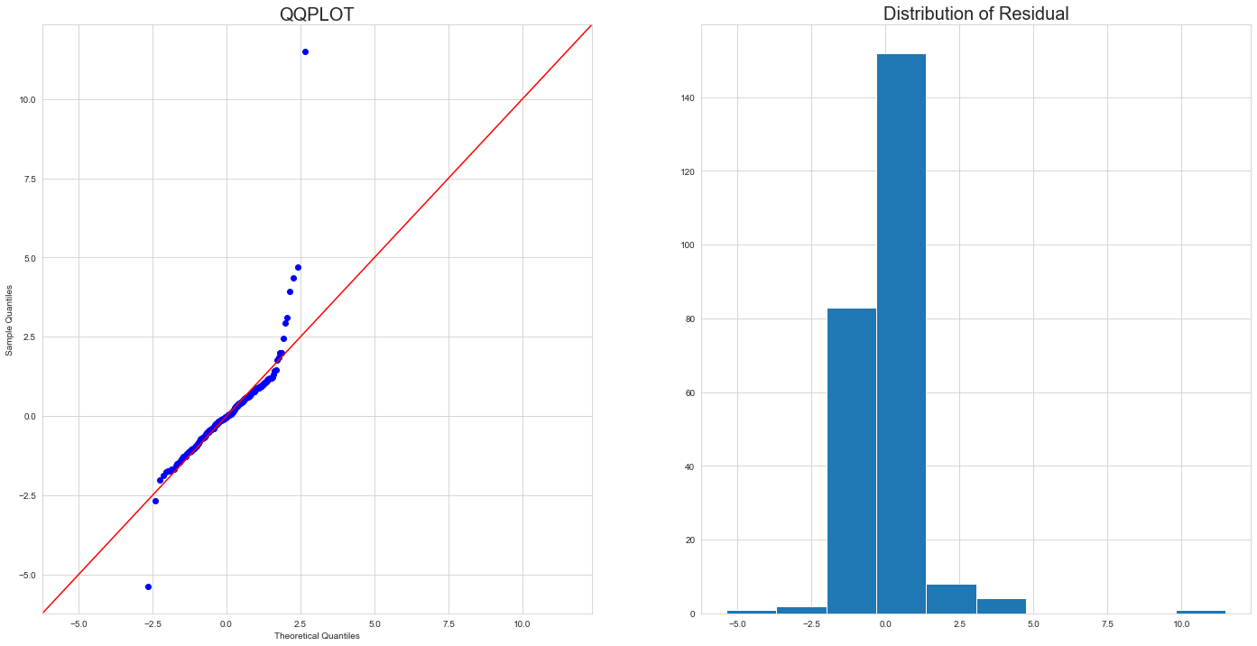

Also as we can see in QQPLOT and distribution of residual, there is some data that looks strange but it is very close to normal distribution. As a result, we can conclude that our data fitted well to SARIMAX(8,1,0,12) model.

4. Forecast

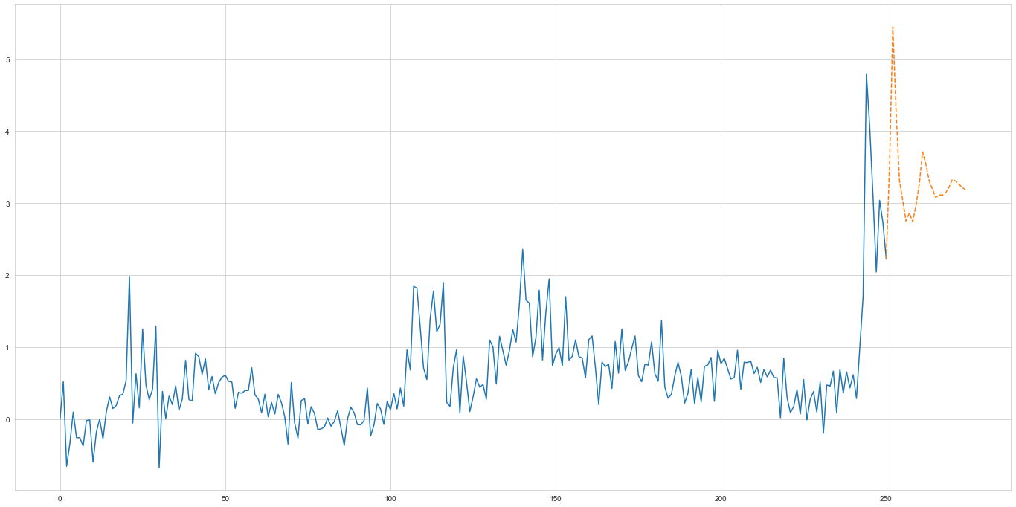

Predict future data through model that I make. I set forecast period as 24 months(2 year). Orange line is forecast data. We can know that percentage change of USA M1 money supply will be increased and after that it will be decreased.

⬩ KOREA M1 money supply

1. Check ACF and PACF

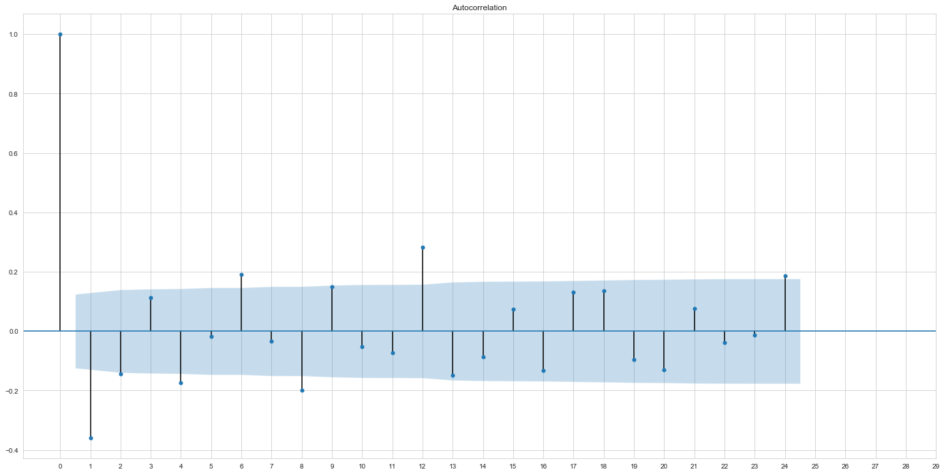

Above image shows autocorrelation function. It looks like cuts off after time lag 1 but there is correlation between time lag 6, 12 and 24.

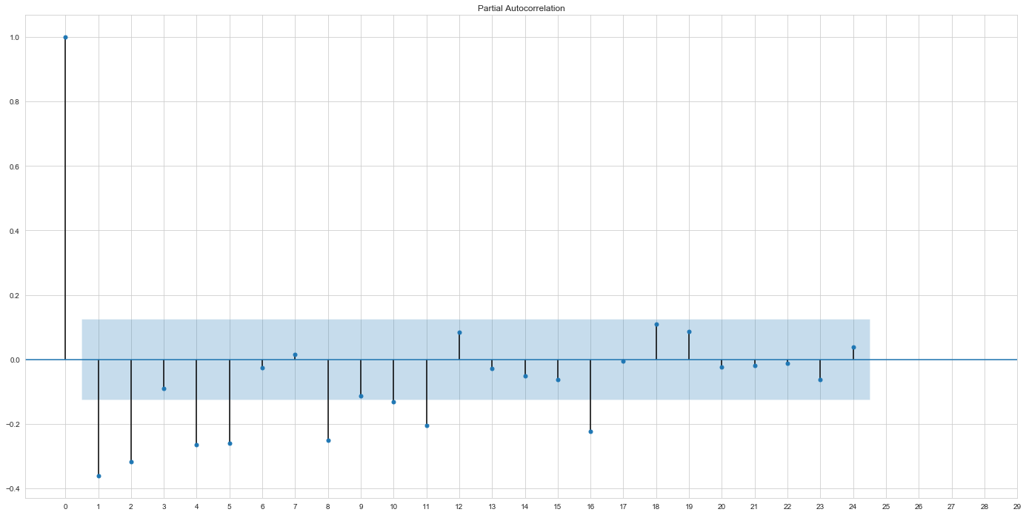

Above image shows partial autocorrelation function. It looks like it tails off after time lag 16. As a result, ARIMA(0,1,12) or ARIMA(16,1,0)

2. Check seasonality

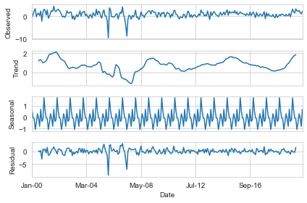

Above image shows seasonality through setting frequency as 12(=1 year). We can know that there is seasonality in our data.

3. Modeling

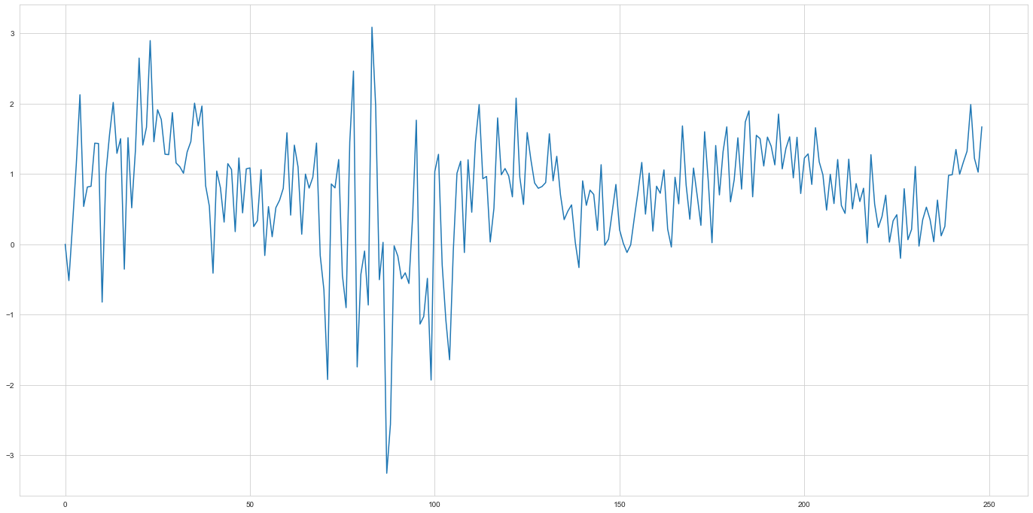

Above image shows data that fitted by our data. I use SARIMAX(0,1,12,12) for seasonality.

[STAT2]

It seems like MA11 and MA12 is not significant

4. Check residual

For checking whether our data fitted well, we should see residual doesn’t have correlation and follow normal distribution.

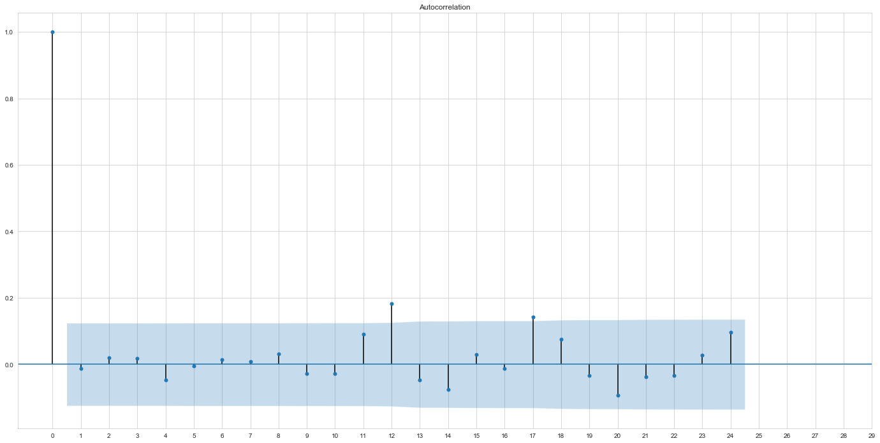

Above image shows autocorrelation function of residual and we can know that there is some point that has correlation but there is almost no correlation

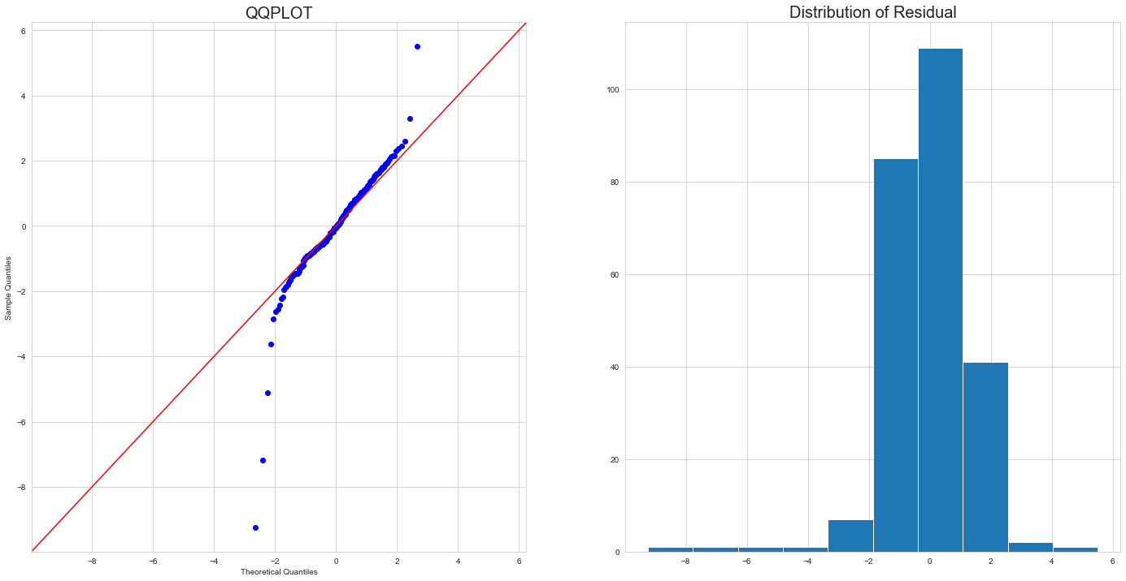

we can see in QQPLOT and distribution of residual, there is some data that looks strange but it is very close to normal distribution. As a result, we can conclude that our data fitted well to SARIMAX(0,1,12,12) model.

4. Forecast

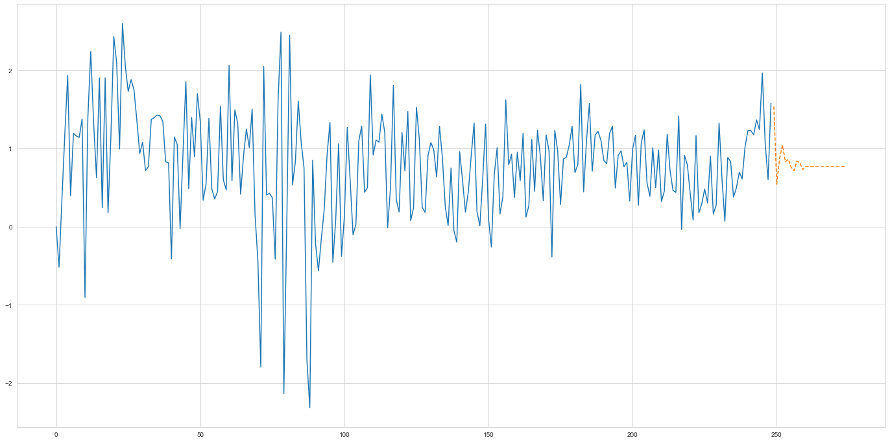

As we did in M1 money supply in USA, period that I predicted is 24 months(2 years). Orange line is data that we forecast through model that we made. We can know that percentage change of M1 money supply of Korea will be decreased in 2 years.

Analysis government expenditure data

* Before we do modeling we should check whether data is stationary or not
* Data unit is percentage change(by quarter)

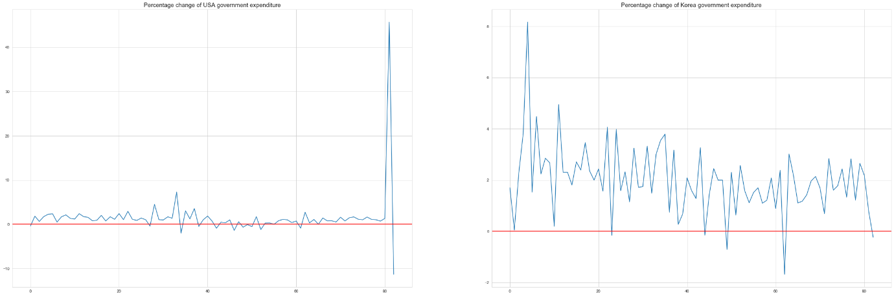

Right image is from USA and the other one is from Korea government. As you can see USA government expand their government expenditure a lot after COVID-19 shock occurred. In contrary, Korea government didn’t expand government expenditure very much.

As you can see, it doesn’t look like stationary process. Mean and variance of time series doesn’t look like constant.

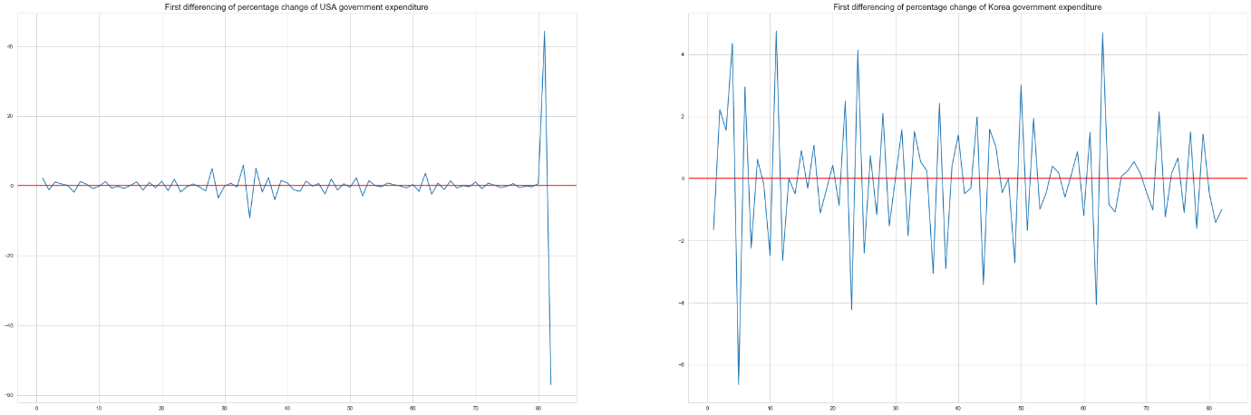

After first differencing, it seems like data is more closer to stationary process. Still, variance of time series is quite large but mean of time series looks like constant. Especially when you look at the USA government expenditure after COVID-19, there is kind of outlier and it is from exogenous shock, it means variance is too large, we can not normalize data after COVID-19.

Modeling and predict government expenditure

* Through analysis government expenditure, we can know what policy government implemented and how much money they expand to market.

⬩ USA M1 money supply

1. Check ACF and PACF

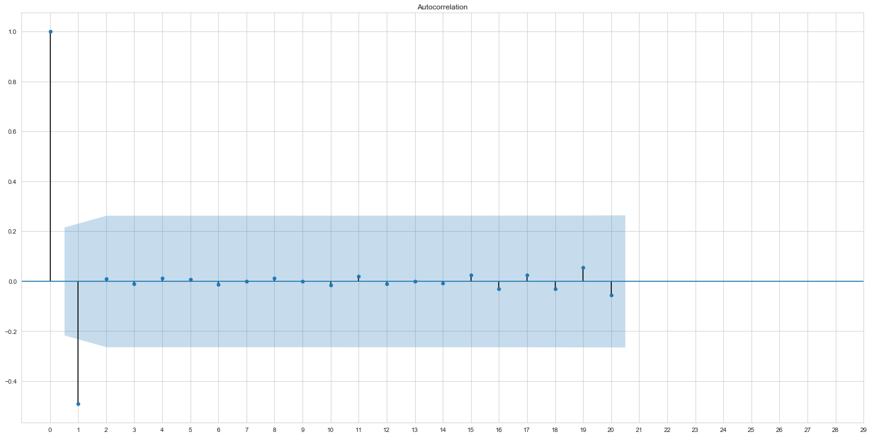

Above image is a autocorrelation function. It looks like it cut off after time lag 1.

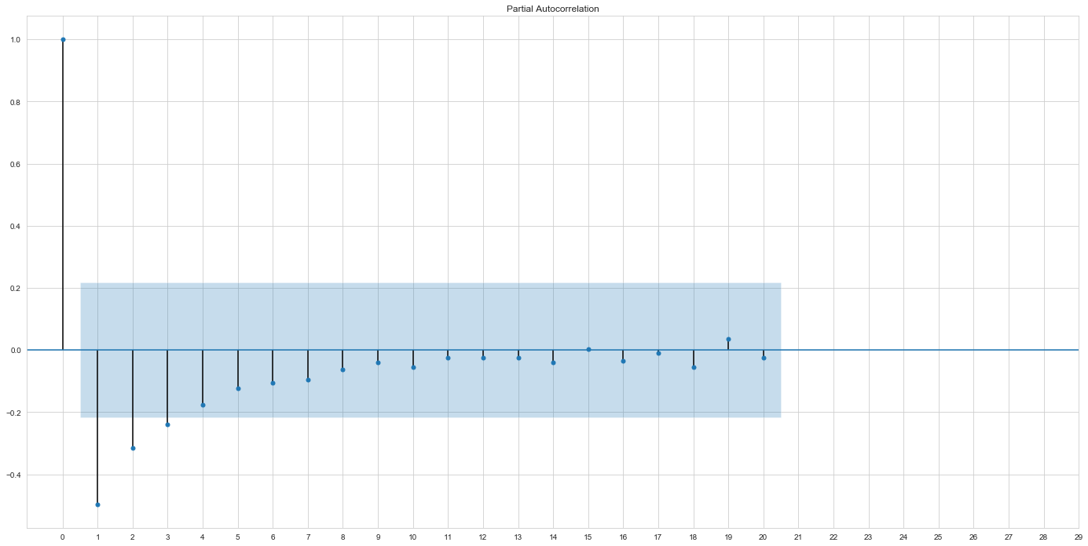

And this is partial autocorrelation function. It looks like it tails off after timer lag 3.

As a result, we can suggest using ARIMA(3,1,0) or ARIMA(0,1,1) model.

2. Modeling

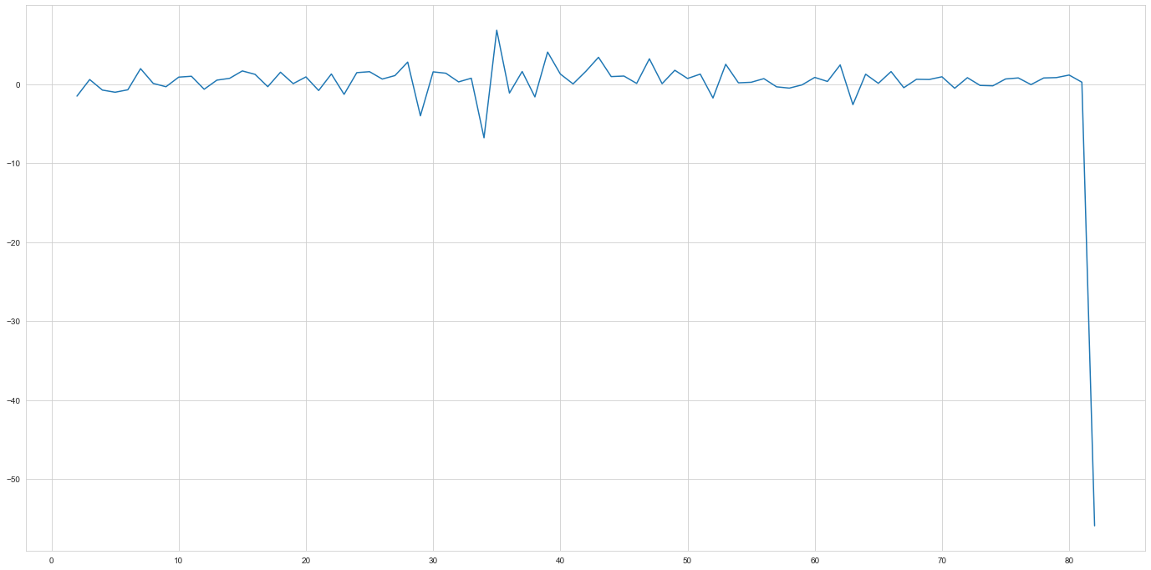

This is result of ARIMA(3,1,0) model.

[STAT3]

All parameters are bigger than std error so they are significant.

3. Check residual

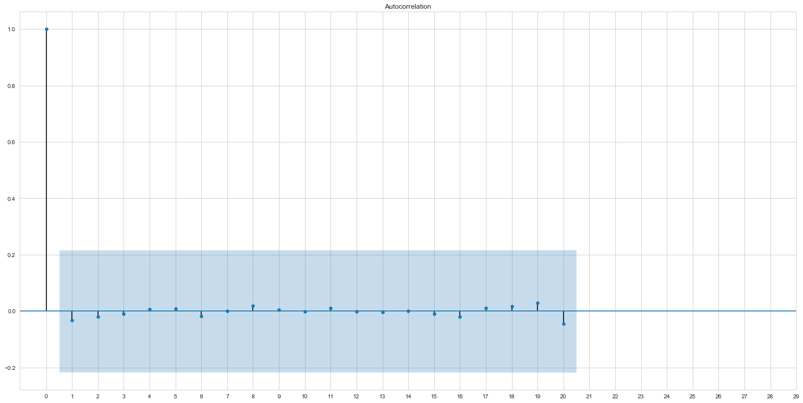

This is image of autocorrelation function of residual. It looks like there are no correlation between any time lag.

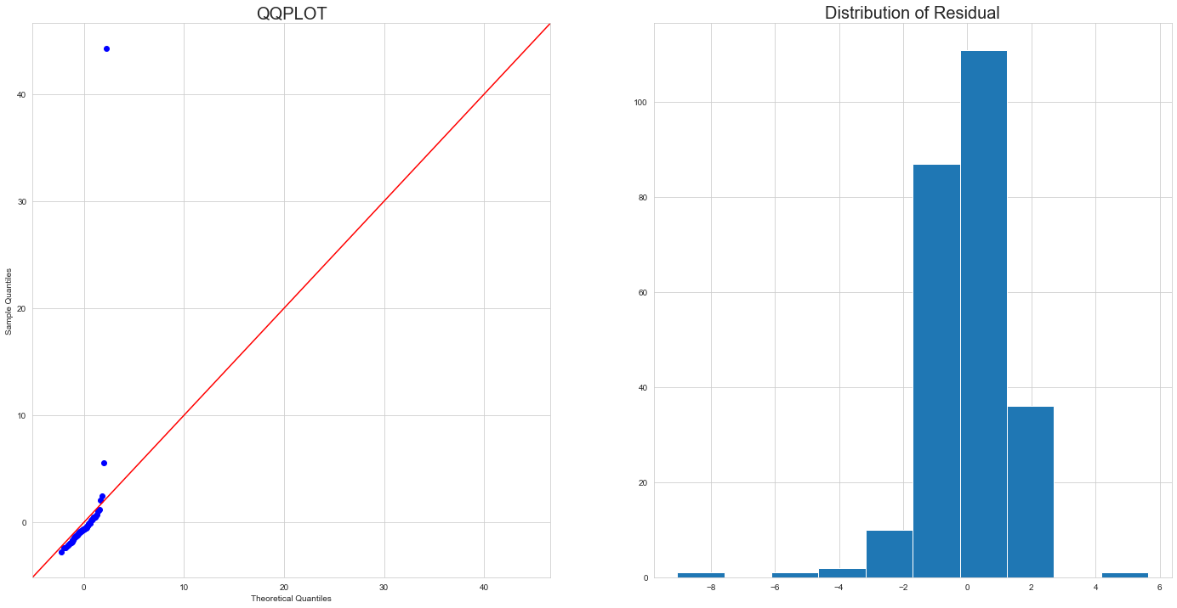

And this is QQPLOT and distribution of residual. As you can see, it follows normal distribution. As a result, we can conclude that data fitted well to ARIMA(3,1,0)

3. Forecast

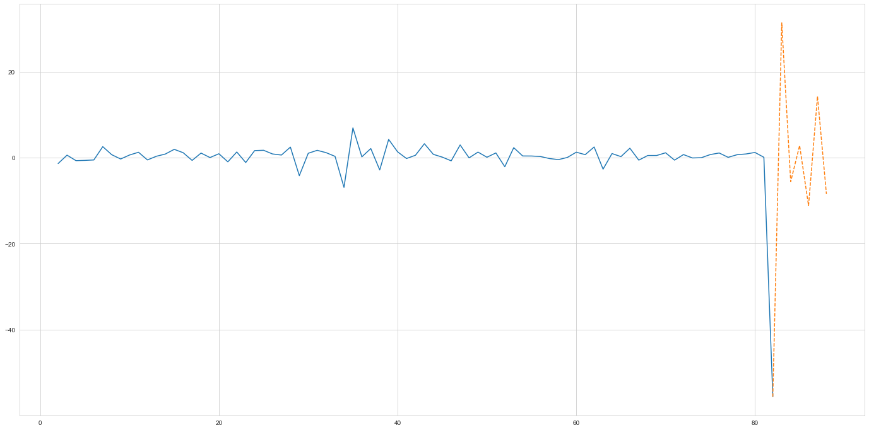

Through ARIMA(3,1,0), I predict 2 years(6 quarter) after 2020 3 quarter. As you can see, it volatile a lot. This is because as I mentioned earlier, USA government expand government expenditure a lot after COVID-19.

⬩ Korea government expenditure

1. Check ACF and PACF

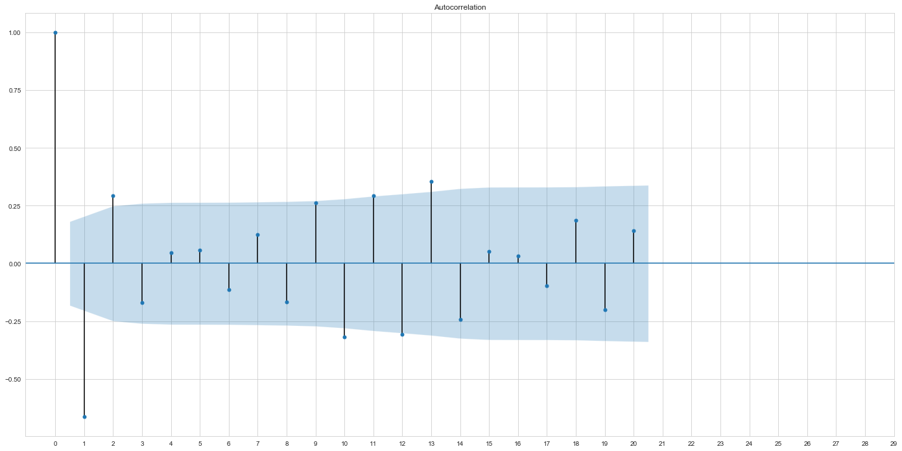

This is autocorrelation function. As you can see, it looks like it cuts off after time lag1 but there is some points like time lag 2, time lag 11 and time lag 13

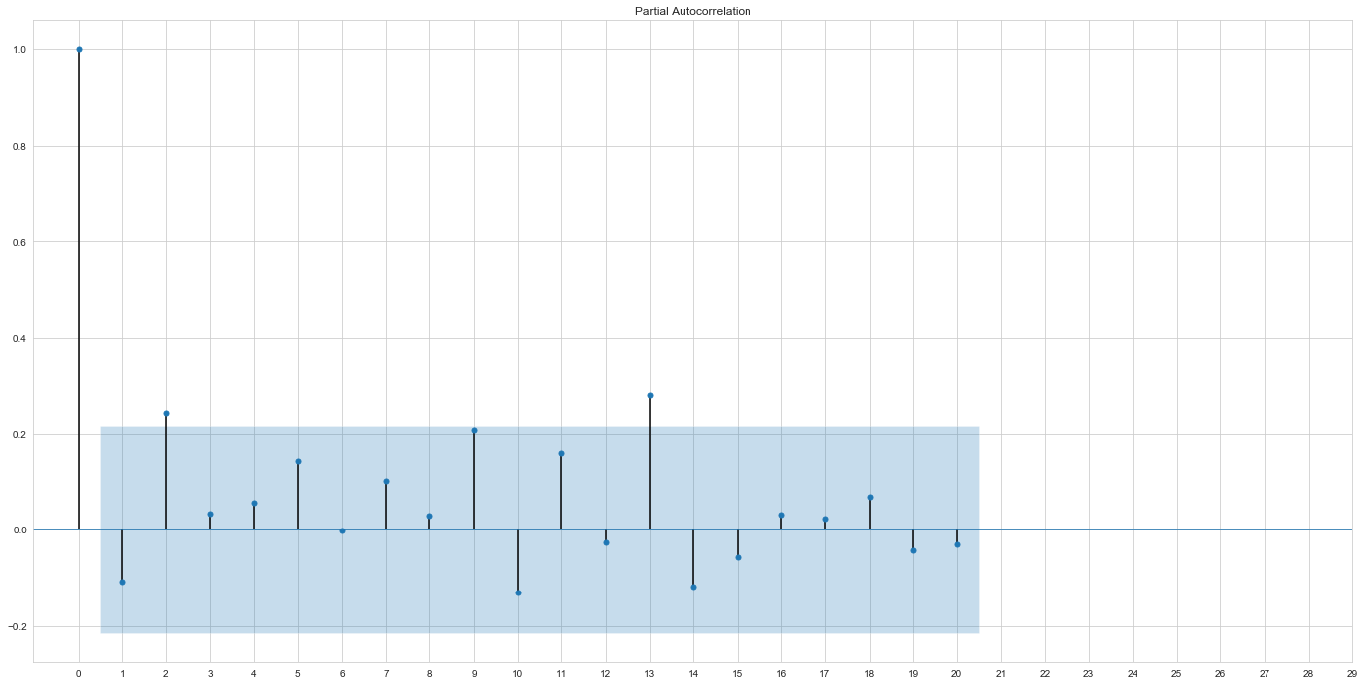

And this is partial correlation function. It looks like there is no tails off. As a result, we can suggest ARIMA(0,1,1), ARIMA(0,1,2), ARIMA(0,1,11), and ARIMA(0,1,13)

2. Modeling

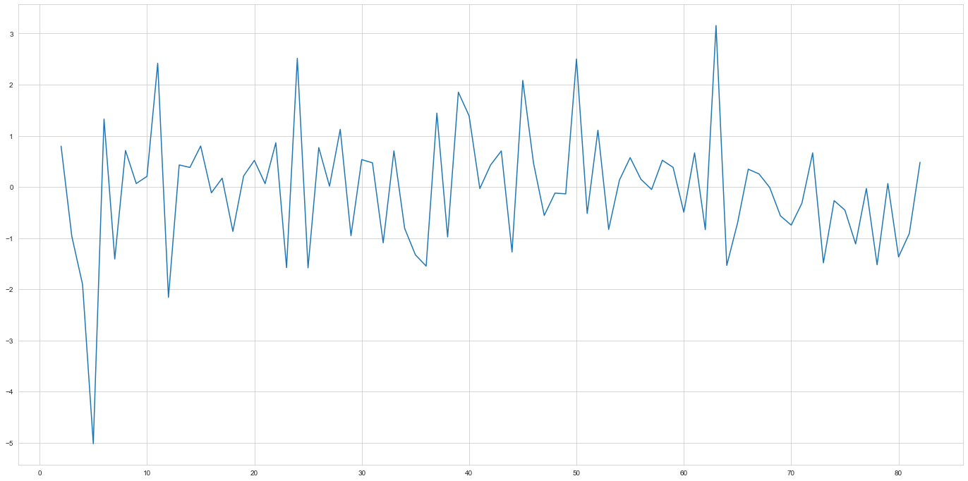

This is result of fitting on ARIMA(0,1,1) model.

[STAT4]

As you can see, all parameters are significant.

3. Check residual

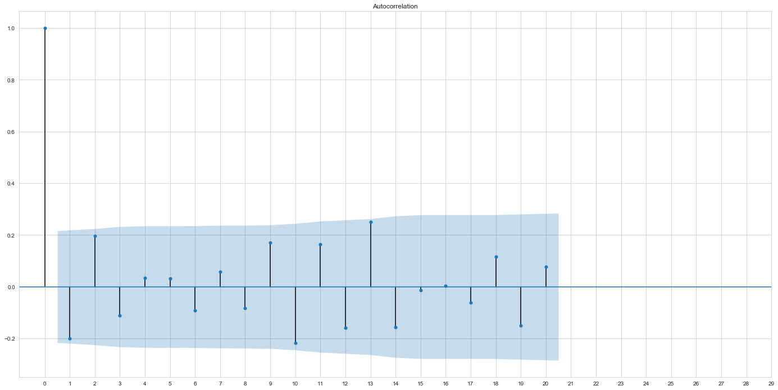

This is autocorrelation of residual and it looks like there is no correlation between time lag. 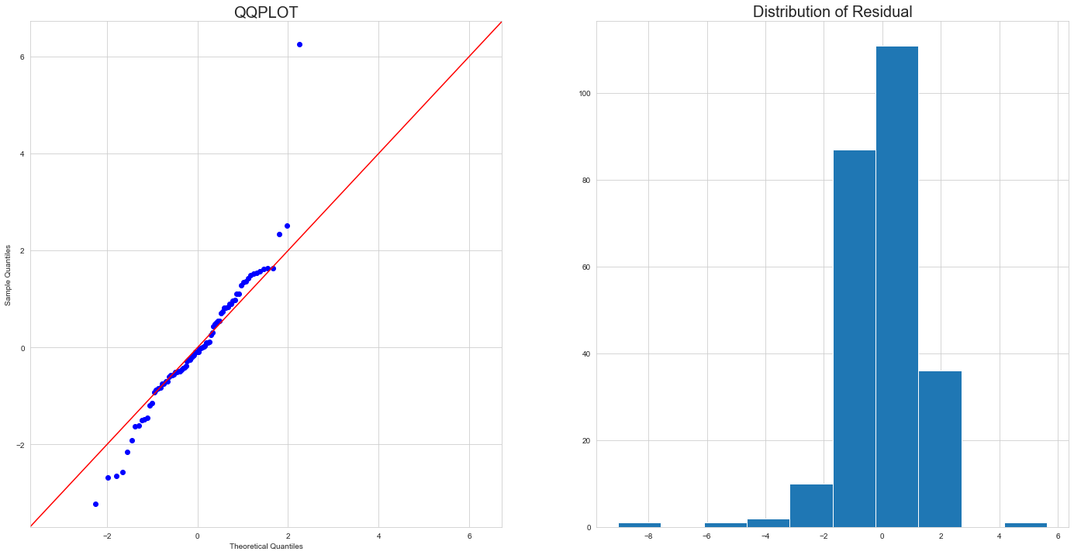We can also use QQPLOT and distribution and as we see both of them, residual follows normal distribution. As a result, we can conclude that data fitted well to ARIMA(0,1,1).

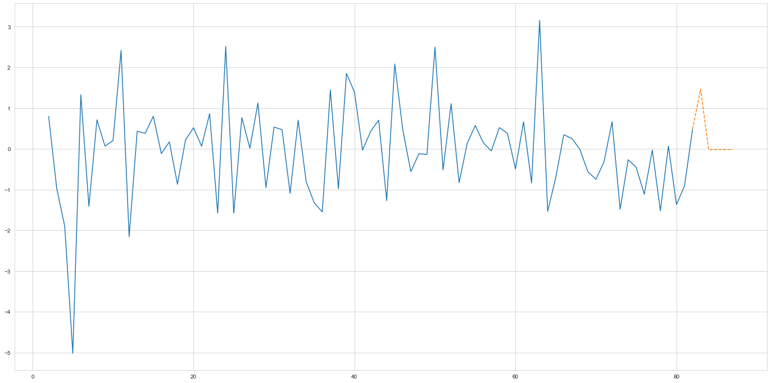

I also predict after 2 years from 2020 third quarter(6 quarter). As a result, we can see government expenditure will be increased.

As we see USA and Korea M1 money supply and government expenditure, USA percentage change is more volatile.

Analysis economy factors through IS-LM model

- As we checked USA government expand more money to market than KOREA, we will assume that there is no change in KOREA fiscal and monetary policy and there is only change in USA government fiscal and monetary expansion.

1. Current situation

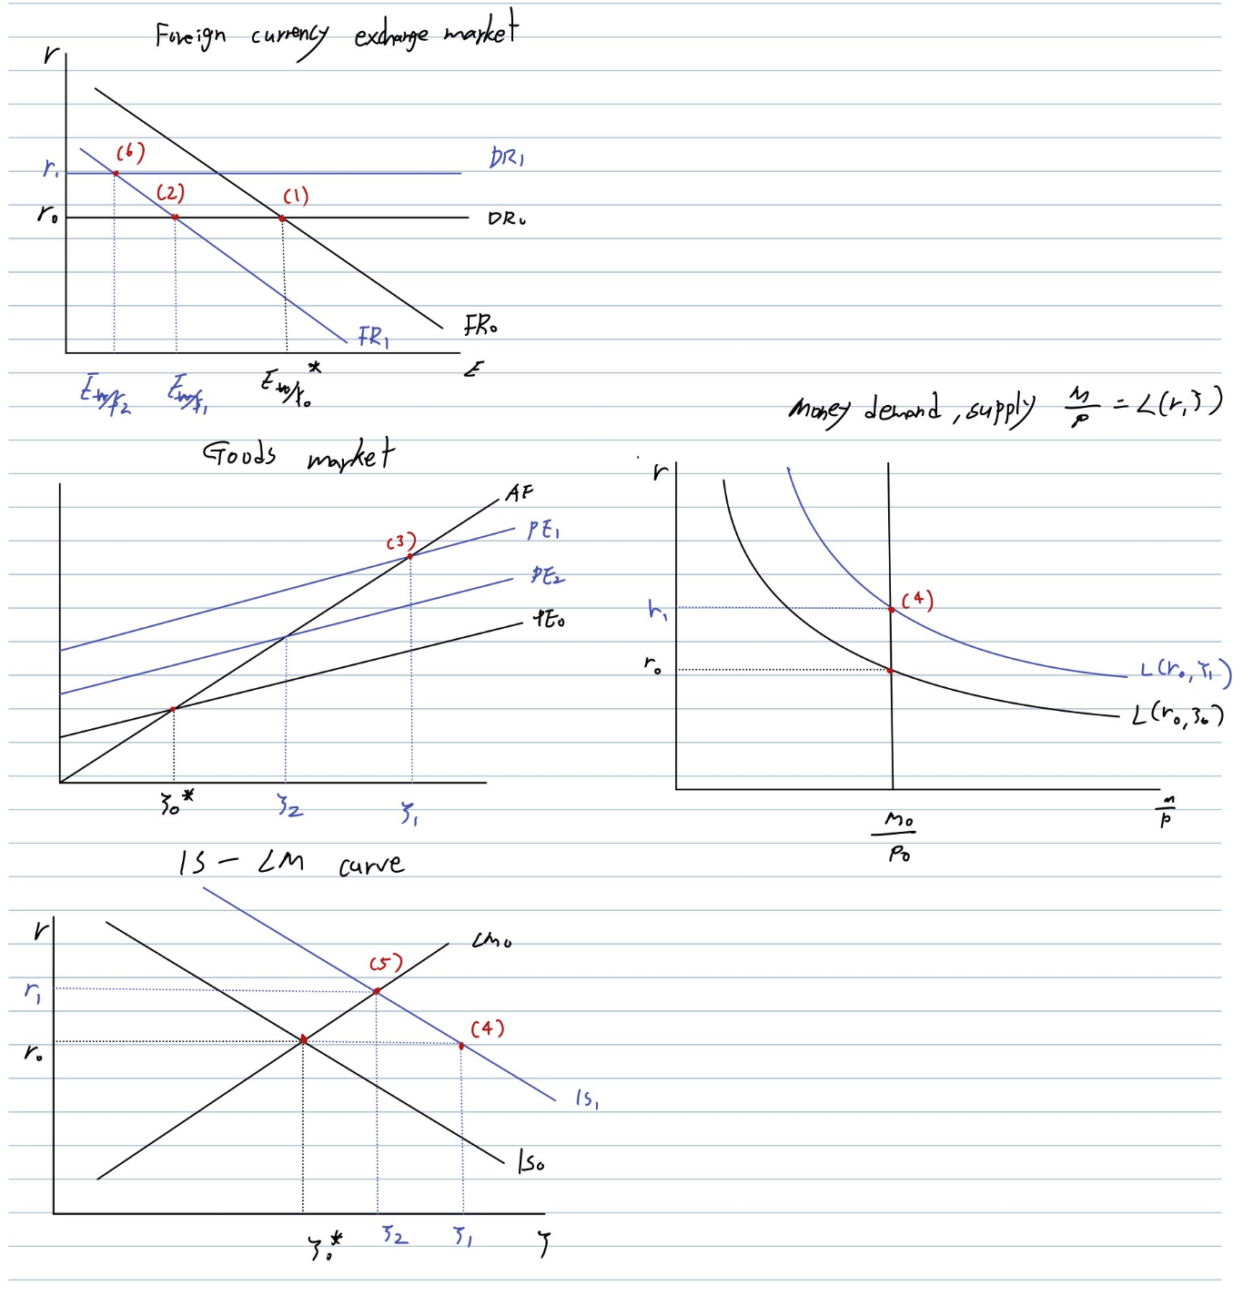

Black line is initial economy line, blue line is economy line indicate after fiscal and monetary policy.

Above image shows IS-LM-FX market diagram. As we seen before, USA expand money much more than Korea through fiscal policy and monetary policy. As a result, USA interest rate decreased. This means that foreign return(USA is foreign country to Korea) decreased too. (1) is initial point. and because foreign return decrease, . This effect makes point (1) moves to point (2) and Korean WON appreciated.

Usually, appreciation of currency makes GDP goes down because it deteriorates trade balance. However, we can observe that Korea GDP restore loss fast.

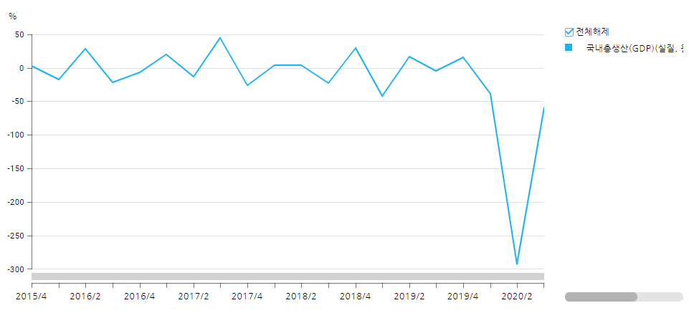

As you can see this graph, Korean GDP decreased a lot in 2020 second quarter but after this period, it increased. I think this is because dollar is spread too much in market so foreign investor try to find place to invest. Because Korea Won appreciated a lot so if they invest in Korea stock, they can get positive valuation effect through exchange rate. For example, if someone buy 100 shares of stock that price is 1200 won (Total 120000 Won = 100 dollar) when exchange rate is 1200 won per dollar. But one day, Korean Won appreciated to 1000 won per dollar. As a result, person who invest in 100 shares of stock can earn . It means that 120-100 = 20. Investor can earn 20 dollars profit because of exchange rate. Like this example, foreign investors invest become larger and domestic economy has been recovered. In short, GDP increased and Korean Won appreciated a lot.

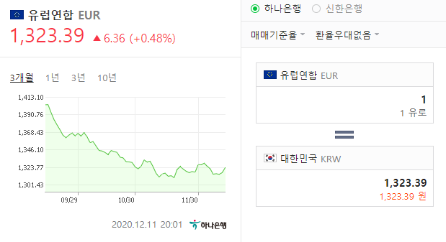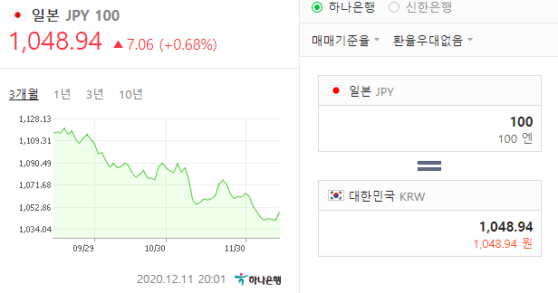

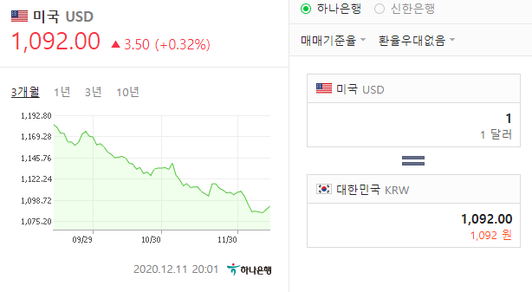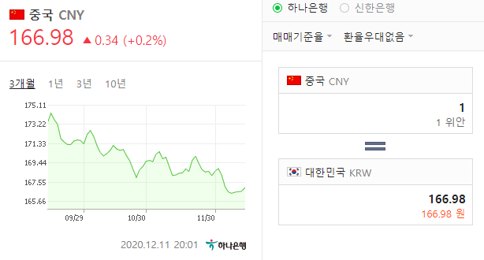

You can see that Korean Won appreciated against all main currency.

So because investor invest a lot, PE=C+G+I+TB increased, point (2) moves to point(3). As money demand increased so interest rate increased (point 4). This will move and and this is called crowding out effect(point 5). As domestic return increased, . And Korean won appreciated against dollar much more.

1. Predict future

As we seen above time-series prediction, USA central bank will decrease money supply and USA government decrease government expenditure. This will increase USA interest rate increased, foreign return increased. Yellow line is line that indicate future.

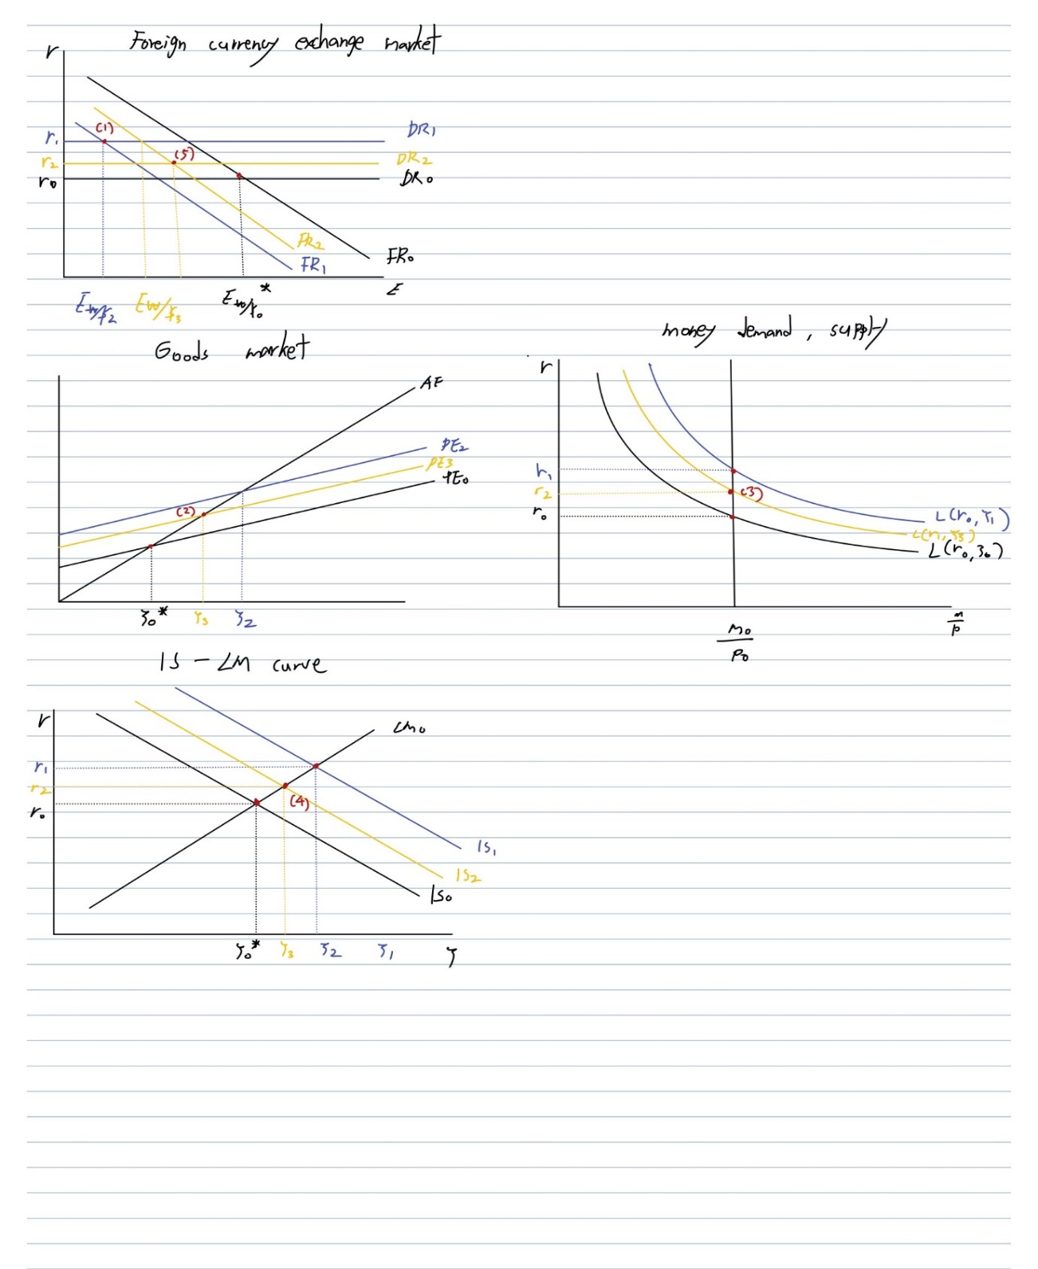

so Korea Won depreciated against US Dollar . So foreign investor exit Korea stock market, , invest decreased, (point2), money demand slightly decreased so (point3), (point4). As interest rate slightly decreased, domestic return decreased, (point5). You can see that all economic factors move closer to initial equilibrium point.

Vector Autoregression model

We can also use VAR to model our economic data. Because each economy factors affect to each other, it is effective to use VAR model.

Data

* GDP, Risk free rate(Korea bond 3 years maturity), consumer consumption, exchange rate, percentage change of government expenditure, price level(real price level), trade balance, KOSPI
* Period of time is 2000~2020 third quarter

1. Modeling

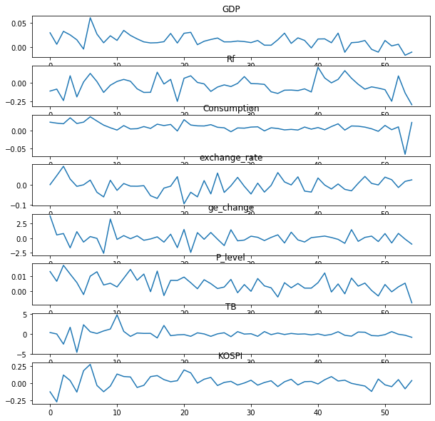

It seems like data fitted well. You can see that GDP, consumption, price level decrease and risk free rate decrease a lot. These economy factors explain negative shock from COVID-19.

2. Check residual

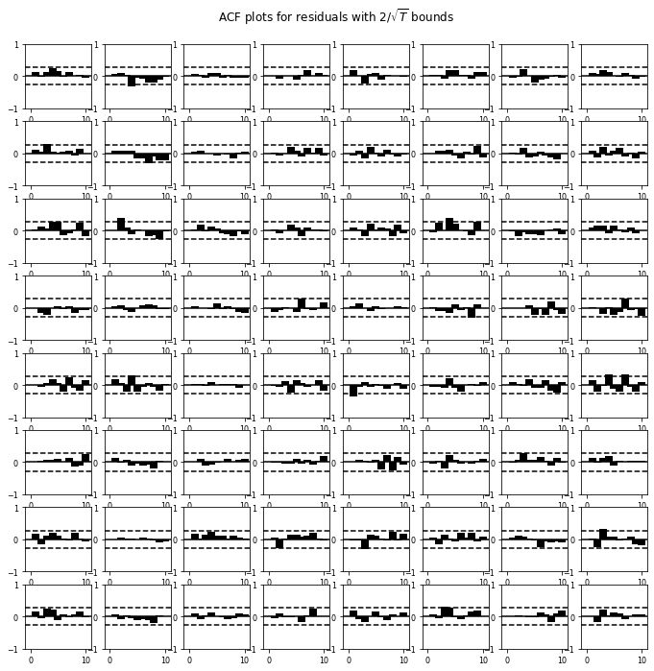

Dotted line indicates standard error when alpha is 0.05. We can see that there is no correlation between variables.

3. Forecast future

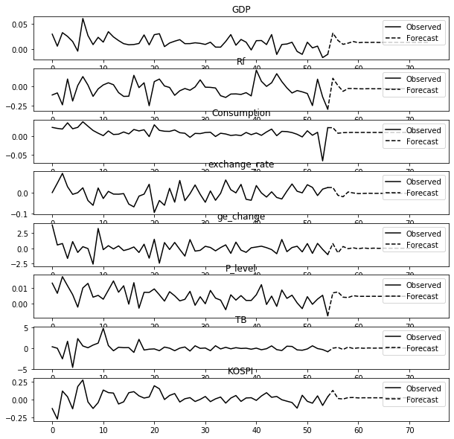

This is forecast of our data. As we analysis future economy through IS-LM-FX model, after monetary policy and fiscal policy, GDP, consumption, risk free rate increased. Also you can see that trade balance doesn’t change much although Korean won appreciated. However, KOSPI increased. It seems like depreciation of US dollar makes Korea stock market boom.

After shock, as we have seen before, all economy factors move to initial values. It is understandable that COVID-19 is short run shock and in long run, it will go back to initial equilibrium point.

Conclusion

Korea recover shock of COVID-19 well through using monetary and fiscal policy, Many people worry about excess appreciation of Korean Won but as we have seen, it doesn’t affect much to trade balance and GDP.

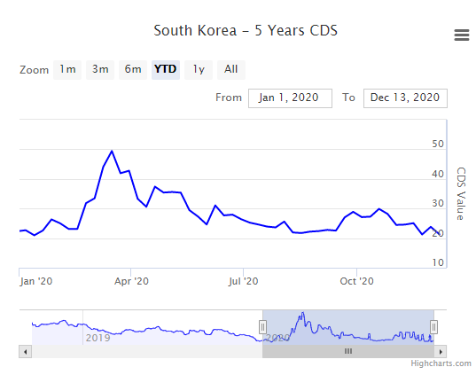

We can see that CDS premium also decreased since 2020 March, and it means Korea economy situation recovered well. In respect of stock market, KOSPI increased because of this shock. However, as we seen, it will go back to initial equilibrium point.

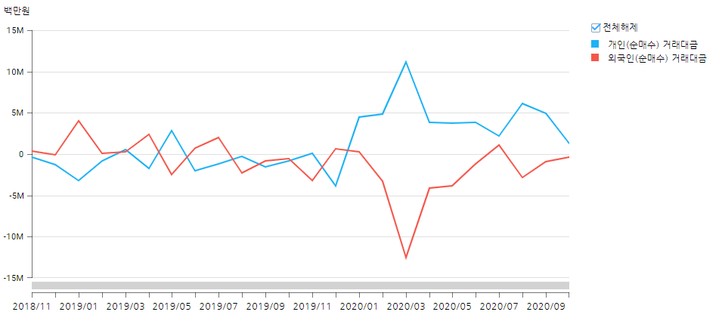

This support that foreign investors increasse their investing in Korea stock market. However, as we can see, domestic individual investing decreased.

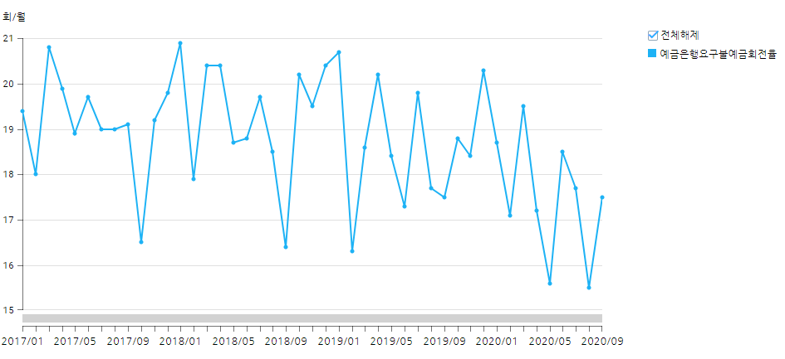

Let’s see currency cycle. We can know that it has decreasing trend. It means that people don’t spend their money much. According to the VAR, consumption increased then what happened? I think it is because even government increase their spending and economy recovered a lot, people expect economy situation is not that very good. As a result, people deposit more money. This phenomenon is called ‘Liquidity trap’. It means as central bank control interest rate very low but because money demand is high, people don’t spend much money than central bank expected. In Korea situation, as government and central bank supply liquidity to market a lot but its effect is lower than government and central bank expectation.

And Korea stock market boomed because of foreign investors, in respect of Korea domestic real market, there can be some gap between real asset and financial asset because stock market boomed however real market still can not follow financial market growth because of low demand. This can be connected to bubble and I think it can be serious problem because if USA reduce supplying money to market, Korea currency premium will be decreased and with Korean high demand of money, there can be negative impact on stock market.

So I think government should not only supply money to market but also they should make people spend their money and increase velocity of money. Or they should control stock market overheated so that government can adjust real asset and financial asset gap.

Appendix

**Data**

FRED, USA government total expenditure (2000~2020)

FRED, USA M1 money supply(2000~2020)

한국은행 경제통계시스템, 국내총생산-정부최종소비지출(2000~2020)

한국은행 경제통계시스템, 통화 및 유동정지표-M1(2000~2020)

한국은행 경제통계시스템, 시장금리-국고채 3년(2000~2020)

한국은행 경제통계시스템, 국내총생산에 대한 지출-민간 최종소비지출(2000~2020)

한국은행 경제통계시스템, 원-달러 환율(2000~2020)

한국은행 경제통계시스템, 국내총생산(2000~2020)

한국은행 경제통계시스템, 소비자물가지수(2000~2020)

한국은행 경제통계시스템, 국제수지-무역수지(2000~2020)

YAHOO FINANCE, KOSPI(2000~2020)

**Graph**

YAHOO FINANCE, S&P 500

NAVER FINANCE, Korean WON exchange rate against USA Dollar, Japanese Yen, Euro and Chines Yuan

WORLD GOVERNMENT BOND, Korean 5 Years CDS

한국은행 경제통계시스템, 증권/재정 – 투자자별 주식거래(2000~2020)

한국은행 경제통계시스템, 예금은행 예금회전율(2000~2020)

STAT1-M1_US

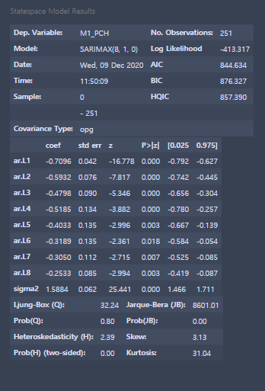

STAT2-M1_KOR

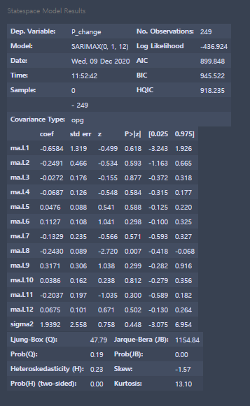

STAT3-Government expenditure-USA

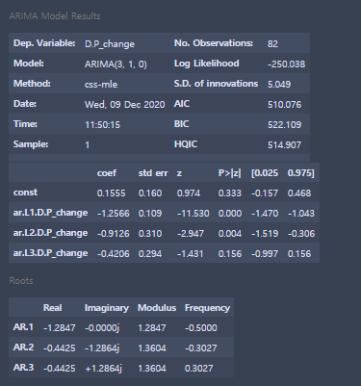

STAT4-Government expenditure-KOR

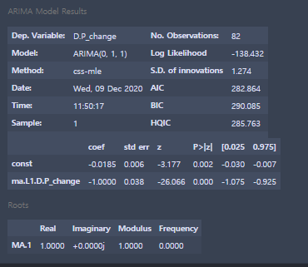

**CODE**

**import** **pandas** **as** **pd**

**import** **seaborn** **as** **sns**

**import** **matplotlib.pyplot** **as** **plt**

**import** **numpy** **as** **np**

**from** **statsmodels.graphics.tsaplots** **import** plot_acf,plot_pacf

**from** **statsmodels.tsa.arima_model** **import** ARIMA

**from** **statsmodels.tsa.statespace** **import** sarimax

**from** **statsmodels.tsa** **import** seasonal

**from** **statsmodels.graphics** **import** gofplots

**import** **datetime**

df1 = pd.read_csv(r"C:\Users\Choi\Desktop\Dataset\Time_project\USA\M1.csv")

df2 = pd.read_csv(r"C:\Users\Choi\Desktop\Dataset\Time_project\KOR\M1.csv")

df1_date = df1.set_index("DATE")

df2_date = df2.set_index("Date")

m1_us = df1.M1_PCH

m1_kor = df2.P_change

sns.set_style("whitegrid")

fig = plt.figure(figsize=(40,13))

**#Plot Dataset**

ax = fig.subplots(1,2)

ax[0].plot(m1_us)

ax[0].set_title("Percentage change of M1 stock in USA",fontsize=15)

ax[0].axhline(y=0, color='r')

ax[1].plot(m1_kor)

ax[1].set_title("Percentage change of M1 stock in KOR",fontsize=15)

ax[1].axhline(y=0, color='r')

**#First differencing**

m1_us_diff = m1_us.diff(periods=1)[1:]

m1_kor_diff = m1_kor.diff(periods=1)[1:]

fig = plt.figure(figsize=(40,13))

**# Plot data that we do First difference**

ax = fig.subplots(1,2)

ax[0].plot(m1_us_diff)

ax[0].set_title("First differencing of percentage change of M1 stock in USA",fontsize=15)

ax[0].axhline(y=0, color='r')

ax[1].plot(m1_kor_diff)

ax[1].set_title("First differencing of percentage change of M1 stock in KOR",fontsize=15)

ax[1].axhline(y=0, color='r')

**M1_US**

**#Plot acf of m1_us**

sns.set_style("whitegrid")

fig = plt.figure(figsize=(24,12))

ax = fig.subplots(1,1)

plot_acf(m1_us_diff,alpha=0.05,zero=**True**,ax=ax)

ax.set_xticks(np.arange(0,30,1))

**#Plot pacf of m1_us**

fig = plt.figure(figsize=(24,12))

ax = fig.subplots(1,1)

plot_pacf(m1_us_diff,alpha=0.05,zero=**True**,ax=ax)

ax.set_xticks(np.arange(0,30,1))

**#Seasonal decompose of m1_us**

ax = seasonal.seasonal_decompose(df1_date, model='additive', freq=12).plot()

**#Fit m1_us to seasonal model**

fig,ax = plt.subplots(1,1,figsize=(24,12))

m1_us_sarima = sarimax.SARIMAX(m1_us,order=(8,1,0,12))

m1_us_result = m1_us_sarima.fit()

m1_us_fit = m1_us_result.predict()

plt.plot(m1_us_fit)

**#m1_us residual**

residual_m1_us = m1_us_result.resid

**#Plot acf of m1_us residaul**

sns.set_style("whitegrid")

fig = plt.figure(figsize=(24,12))

ax = fig.subplots(1,1)

plot_acf(residual_m1_us,alpha=0.05,zero=**True**,ax=ax)

ax.set_xticks(np.arange(0,30,1))

**#Plot QQPLOT and distribution of m1_us**

fig = plt.figure(figsize=(24,12))

ax = fig.subplots(1,2)

gofplots.qqplot(residual_m1_us,ax=ax[0],line="45")

ax[0].set_title("QQPLOT",fontsize=20)

ax[1].hist(residual_m1_us)

ax[1].set_title("Distribution of Residual",fontsize=20)

**#Plot prediction of m1_us**

m1_us_pred = m1_us_result.predict(start=250,end=274)

fig = plt.figure(figsize=(24,12))

ax = fig.subplots(1,1)

ax = plt.plot(m1_us_fit)

ax = plt.plot(m1_us_pred,"--")

**M1_KOR**

**#Plot m1_kor_diff acf**

sns.set_style("whitegrid")

fig = plt.figure(figsize=(24,12))

ax = fig.subplots(1,1)

plot_acf(m1_kor_diff,alpha=0.05,zero=**True**,ax=ax)

ax.set_xticks(np.arange(0,30,1))

**#Plot m1_kor_diff pacf**

fig = plt.figure(figsize=(24,12))

ax = fig.subplots(1,1)

plot_pacf(m1_kor_diff,alpha=0.05,zero=**True**,ax=ax)

ax.set_xticks(np.arange(0,30,1))

**#Seasonal decompose of m1_kor_diff**

ax = seasonal.seasonal_decompose(df2_date, model='additive', freq=12).plot()

**#Plot m1_us_diff to sarimax**

m1_kor_sarima =sarimax.SARIMAX(m1_kor,order=(0,1,12,12))

m1_kor_result = m1_kor_sarima.fit()

m1_kor_fit = m1_kor_result.predict()

fig = plt.figure(figsize=(24,12))

ax = fig.subplots(1,1)

ax = plt.plot(m1_kor_fit)

**#Residual of m1_kor**

residual_m1_kor = m1_kor_result.resid

**#Plot residual of m1_kor**

sns.set_style("whitegrid")

fig = plt.figure(figsize=(24,12))

ax = fig.subplots(1,1)

plot_acf(residual_m1_kor,alpha=0.05,zero=**True**,ax=ax)

ax.set_xticks(np.arange(0,30,1))

**#Plot QQPLOT and distribution of residual**

fig = plt.figure(figsize=(24,12))

ax = fig.subplots(1,2)

gofplots.qqplot(residual_m1_kor,ax=ax[0],line="45")

ax[0].set_title("QQPLOT",fontsize=20)

ax[1].hist(residual_m1_kor)

ax[1].set_title("Distribution of Residual",fontsize=20)

**#Plot prediction of m1_kor**

m1_kor_pred = m1_kor_result.predict(start=249,end=274)

fig = plt.figure(figsize=(24,12))

ax = fig.subplots(1,1)

ax = plt.plot(m1_kor_fit)

ax = plt.plot(m1_kor_pred,"--")

**#Load government expenditure**

df3 = pd.read_csv(r"C:\Users\Choi\Desktop\Dataset\Time_project\KOR\GE.csv")

df4 = pd.read_csv(r"C:\Users\Choi\Desktop\Dataset\Time_project\USA\GE.csv")

ge_kor = df3["P_change"]

ge_us = df4["P_change"]

**#Plot government expenditure**

sns.set_style("whitegrid")

fig = plt.figure(figsize=(40,13))

ax = fig.subplots(1,2)

ax[0].plot(ge_us)

ax[0].set_title("Percentage change of USA government expenditure",fontsize=15)

ax[0].axhline(y=0, color='r')

ax[1].plot(ge_kor)

ax[1].set_title("Percentage change of Korea government expenditure",fontsize=15)

ax[1].axhline(y=0, color='r')

**#Do first difference**

ge_kor_diff = ge_kor.diff(periods=1)[1:]

ge_us_diff = ge_us.diff(periods=1)[1:]

**#Plot data that we do first differencing**

fig = plt.figure(figsize=(40,13))

ax = fig.subplots(1,2)

ax[0].plot(ge_us_diff)

ax[0].set_title("First differencing of percentage change of USA government expenditure",fontsize=15)

ax[0].axhline(y=0, color='r')

ax[1].plot(ge_kor_diff)

ax[1].set_title("First differencing of percentage change of Korea government expenditure",fontsize=15)

ax[1].axhline(y=0, color='r')

**GE_US**

**#Plot GE_US acf**

sns.set_style("whitegrid")

fig = plt.figure(figsize=(24,12))

ax = fig.subplots(1,1)

plot_acf(ge_us_diff,alpha=0.05,zero=**True**,ax=ax)

ax.set_xticks(np.arange(0,30,1))

**#Plot GE_US pacf**

sns.set_style("whitegrid")

fig = plt.figure(figsize=(24,12))

ax = fig.subplots(1,1)

plot_pacf(ge_us_diff,alpha=0.05,zero=**True**,ax=ax)

ax.set_xticks(np.arange(0,30,1))

**#Fit GE_US**

fig,ax = plt.subplots(1,1,figsize=(24,12))

ge_us_arima = ARIMA(ge_us,order=(3,1,0))

ge_us_result = ge_us_arima.fit()

ge_us_fit = ge_us_result.predict()

plt.plot(ge_us_fit)

**#Residual of ge_us**

residual_ge_us = ge_us_result.resid

**#Plot ACF of residual**

sns.set_style("whitegrid")

fig = plt.figure(figsize=(24,12))

ax = fig.subplots(1,1)

plot_acf(residual_ge_us,alpha=0.05,zero=**True**,ax=ax)

ax.set_xticks(np.arange(0,30,1))

**#Plot QQPLOT and distribution of residual**

fig = plt.figure(figsize=(24,12))

ax = fig.subplots(1,2)

gofplots.qqplot(residual_ge_us,ax=ax[0],line="45")

ax[0].set_title("QQPLOT",fontsize=20)

ax[1].hist(residual_m1_kor)

ax[1].set_title("Distribution of Residual",fontsize=20)

**#Plot prediction**

ge_us_pred = ge_us_result.predict(start=82,end=87)

fig = plt.figure(figsize=(24,12))

ax = fig.subplots(1,1)

ax = plt.plot(ge_us_fit)

ax = plt.plot(ge_us_pred,"--")

**GE_KOR**

**#Plot GE_KOR ACF**

sns.set_style("whitegrid")

fig = plt.figure(figsize=(24,12))

ax = fig.subplots(1,1)

plot_acf(ge_kor_diff,alpha=0.1,zero=**True**,ax=ax)

ax.set_xticks(np.arange(0,30,1))

**#Plot GE_KOR PACF**

sns.set_style("whitegrid")

fig = plt.figure(figsize=(24,12))

ax = fig.subplots(1,1)

plot_pacf(ge_kor,alpha=0.05,zero=**True**,ax=ax)

ax.set_xticks(np.arange(0,30,1))

**#Fit ge_kor**

fig,ax = plt.subplots(1,1,figsize=(24,12))

ge_kor_arima = ARIMA(ge_kor,order=(0,1,1))

ge_kor_result = ge_kor_arima.fit()

ge_kor_fit = ge_kor_result.predict()

plt.plot(ge_kor_fit)

**#Residual of ge_kor**

residual_ge_kor = ge_kor_result.resid

**#Plot ACF of residual**

sns.set_style("whitegrid")

fig = plt.figure(figsize=(24,12))

ax = fig.subplots(1,1)

plot_acf(residual_ge_kor,alpha=0.05,zero=**True**,ax=ax)

ax.set_xticks(np.arange(0,30,1))

**#Plot QQPLOT and distribution of residual**

fig = plt.figure(figsize=(24,12))

ax = fig.subplots(1,2)

gofplots.qqplot(residual_ge_kor,ax=ax[0],line="45")

ax[0].set_title("QQPLOT",fontsize=20)

ax[1].hist(residual_m1_kor)

ax[1].set_title("Distribution of Residual",fontsize=20)

**#Plot prediction of GE_KOR**

ge_kor_pred = ge_kor_result.predict(start=82,end=87)

fig = plt.figure(figsize=(24,12))

ax = fig.subplots(1,1)

ax = plt.plot(ge_kor_fit)

ax = plt.plot(ge_kor_pred,"--")

**VAR**

**from** **statsmodels.tsa.api** **import** VAR

**import** **pandas** **as** **pd**

**import** **numpy** **as** **np**

**import** **statsmodels.api** **as** **sm**

**from** **statsmodels.tsa.base.datetools** **import** dates_from_str

**import** **matplotlib.pyplot** **as** **plt**

**import** **seaborn** **as** **sns**

df = pd.read_csv(r"C:\Users\Choi\Desktop\Dataset\Time_project\KOR\VAR\VAR.csv")

date = df[['year', 'quarter']].astype(int).astype(str)

**#Make Datetime index to fit data**

quarter = date["year"] + "Q" + date["quarter"]

quarter = dates_from_str(quarter)

df.index = pd.DatetimeIndex(quarter)

df.drop(labels=["year","quarter"],inplace=**True**,axis=1)

data = np.log(df).diff().dropna()

**#Fit data**

model=VAR(data)

result = model.fit()

ax = result.plot()

ax = result.plot_acorr()

sns.set_style("whitegrid")

ax = result.plot_forecast(20,plot_stderr=**False**)

**Preprocess KOSPI Data(Monthly → Quarter)**

**import** **pandas** **as** **pd**

**import** **numpy** **as** **np**

**import** **matplotlib.pyplot** **as** **plt**

df = pd.read_csv(r"C:\Users\Choi\Desktop\Dataset\Time_project\KOR\VAR\KOSPI.csv")

result = []

**for** i **in** range(0,249,3):

n = i+3

average = np.average(df["Adj Close"][i:n])

result.append(average)

df2 = pd.DataFrame({

"KOSPI" : result

})

df2.to_csv(r"C:\Users\Choi\Desktop\Dataset\Time_project\KOR\VAR\k.csv",index=**False**)